Group Project ECON 220
Group Members: Curtis Nickle, Nahid Yari
Instructor: Muhebullah Karimzada

the impact of digital transformation on Global Labour Markets

Introduction:
Digital transformation has been continually reforming not just business but society itself. It is the integration of digital technologies in all areas of business, society, and life, and it fundamentally alters how organizations operate and deliver value to their customers. Digital transformation is not just the creation of new technologies but the widespread adoption of them, such as automation, data analytics, blockchain, computing, and AI. As continuous innovation will always be taking place the digital world will continue creating the need for business to be able to adapt. The impact of global digital transformation has been seen throughout history and will continue to change, affecting the global labour market as its impact becomes increasingly evident. This continuous change will reshape industries, job roles, and the skills required to be a successful employer.
The significance of examining digital transformation is crucial in order to try and make predictions and control the everchanging uncertain labour market. In our era automation is steadily replacing manual tasks, resulting in widespread fear amongst employers, this being said the creation of new jobs is also present, but they pose their unique problems. People are faced with the challenges of job displacement, the need for reskilling and frictional unemployment. These shifts increase the need for policymakers, business leaders, and workers to be informed about negating the negatives of digital transformation and reaping the positives.

To put it simply this paper will explore the impact of digital transformation on global markets. With a focus on the impact on the employer (job displacement, shifting skills needs, Emerging opportunities), the policy maker (what they can do for their country to protect its employers and employers), and the business (how can they protect their people and bottom line).
Literature Review: Summary of existing research and theories related to the topic.
The most prominent piece of information that has proven to be consistent across a multitude of academic journals is that “there is one certainty: New technologies will dramatically change the nature of work across all industries and occupations.” (Sarabedeen, 2023) when looking at some of the basic and oldest economic theories such as the Solow growth model, it lacked the ability to evaluate the modern technology-driven market because knowledge capital was not considered a variable in the model. Knowledge is one of the key factors when considering how well a firm can utilize digital technology. The first relevant theory to this topic that became widespread came from economist Joseph Schumpeter who posed the idea of creative destruction in 1942 which is “the dismantling of long-standing practices in order to make way for innovation and is seen as a driving force of capitalism”. (Kopp, 2012) In our topic, digital innovation is dismantling long-standing practices and in order to survive in this capitalistic environment firms must adapt, and employers must increase their level of human capital in order to survive.
Looking into much more modern literature, there seem to be four prominent theories on the approaches firms will take to prepare for digital changes. The theories are that firms are becoming increasingly adaptable and flexible, there will be increased job segmentation and polarization, shifts in the global labour ecosystem, and finally the theory of co-evolution of technology and labour markets. Many of these papers agree with the idea that those unable to adapt whether they are a firm or a worker will not survive. In developed or first-world countries the idea of the issue of job polarization seems to be less prominent. This results from the idea that even lower-class individuals in a developed country will have access to technologies as well as options to upgrade their human capital, as one could take out student loans and attend a trade school. This being said a cohesive idea that many pieces of literature illustrate is that the impact of digital technologies will have a much more significant and negative impact on developing countries and markets. This is a result of the idea that “a new segmentation of the labour market might be emerging, based on the technological requirements of jobs” (Daniele, 2024), which a lot of those in developing countries do not have access to.
The issue with papers trying to predict the impact of digital change is that they are analyzing the past to derive models in an effort to predict the future. The recurring problem with these theories is that although they are logically derived predictions, in some cases the capitalistic/globalized market does not respond in a predictable manner. The Bank Of Canada is wary of the future and in a 2023 report stated that “No consensus exists on the effects of digitalization on aggregate wages. Empirical research is mixed, and theoretical models are ambiguous as to the predicted effects”. (Chernoff, 2023)
When analyzing theories about how policymakers should respond across the globe, “Evidence is clear that increasing social and economic inequalities resulting from digital transformation will occur if they are not proactively addressed by policymakers” (Fountaine, 2019). It is a unanimous conclusion that policymakers must address the issue of DT globally. Inequalities are becoming greater between the social classes in a given country (the middle class is becoming a thing of the past), And there are more significant inequalities between countries as those who have the ability to adopt DT will dominate and destroy small developing economies of poorer countries. Policymakers have an essential role to play in both protecting their country's economies by restricting/limiting foreign trade and by implementing policies to protect the working-class people within the country.

Analysis: In-depth analysis of the chosen topic, including current trends, data, and case studies.

The first significant trend towards digital transformation has been seen with COVID-19 which resulted in a rapid shift to remote working. Remote working refers to the work done outside of the traditional office, often relying on technological and digital tools such as computers, mobile, the internet etc. Since COVID-19 has ended, industries still kept remote working as their work culture which furthermore increased the demand for different digital tools. Remote working has impacted several aspects of labour markets, including human resources, well-being, technology adoption, leadership and socioeconomic aspects ( Drago, & Errichiello, 2024, 1). However, there are specific industries that cannot adapt to remote working such as consumer-facing industries, healthcare, manufacturing and production, fast food production and retail. Industries that adopt this trend have been facing several challenges while enhancing their performance. Increase in inequality and disparities, workers with little knowledge of how to use digital tools have been negatively affected as a result of the lack of digital knowledge, hence requiring the workers to learn new skills related to digital systems. This has created significant challenges for human resources including training employees on how to adapt to new technologies, lack of communication and control of work environment and performance management. Studies have also shown that remote work has a negative impact on the well-being of workers as working from home has led to more stress and burnout. Data shows industries that adopted remote working and the top industries are technological, agencies, consultation, finance & insurance, engineering & Science widely impacted by digital transformation in the labour market.

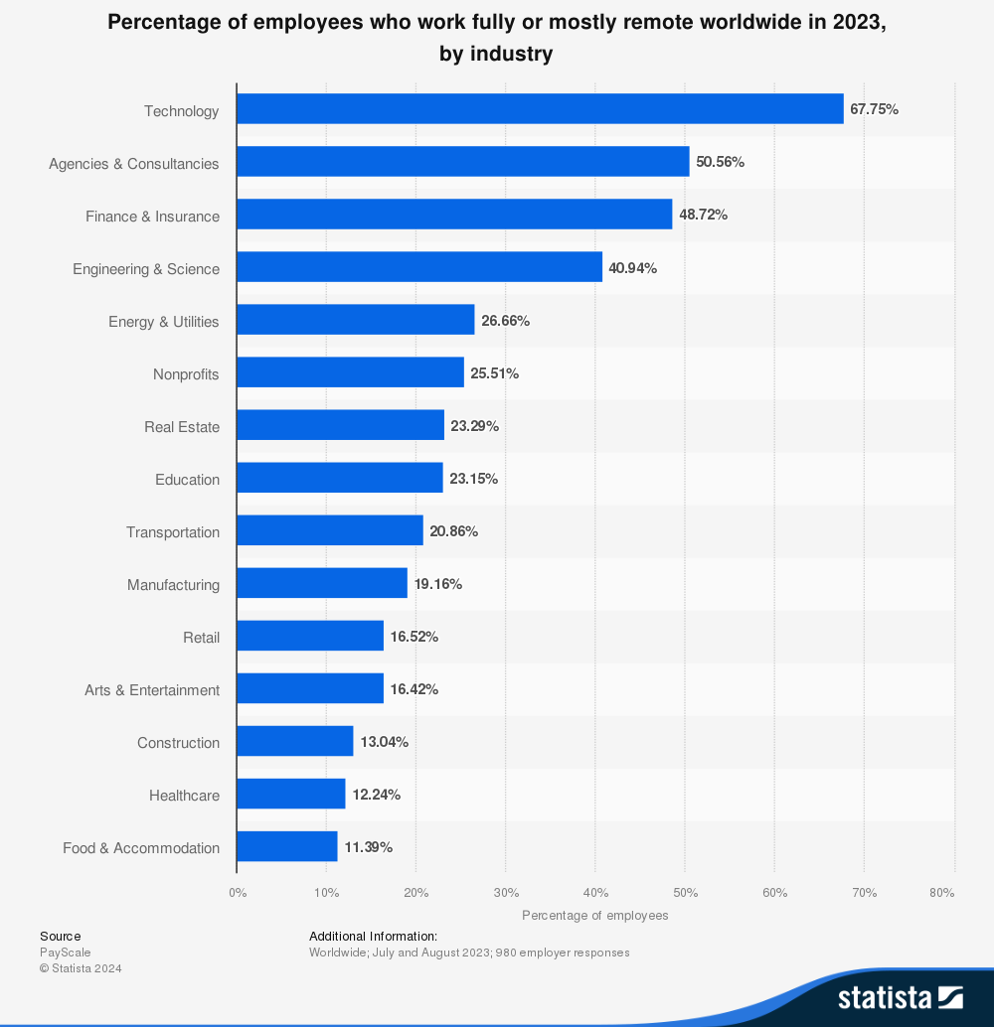
Source: Statistica published by Ahmed Sharif, June 14, 2024
Moreover, digital transformation has contributed to the creation of jobs and increasing employment in specific sectors, lowering costs and increasing productivity in labour markets. “The findings show that digital transformation is expected to create 22% of new employment (760,000) by 2020 in the USA alone, and 25,000 innovative jobs annually in Australia” ( Sarabdeen & Alofayson 2023). These jobs are primarily in tech industries, which 1% increase in job creation would lead to a 0.07% decrease in unemployment. In some cases, digital transformation has led to a decrease in employment due to the gap in skills and knowledge of technologies as well as the impact of substituting machines and robotics with humans. For example, self-checkouts at grocery stores instead of the traditional retail method by cashiers.

Another trend associated with digital transformation is the increasing demand for digital literacy and skills. Workers with better digital skills are likely to find better jobs. The industries are also looking for employees who are better skilled in digital technologies. Among institutions and universities, there is a heavy demand for incorporating courses and materials that are focused on digital skill sets. The whole globalization process has led people, countries and the world toward the trend of becoming more tech-heavy and increasing in demand for digital skills. Increasing digital skills has opportunities and challenges. Demand for highly skilled workers is increasing and the middle-skilled workers would be left off. This trend is called job polarization which is predominant in developed countries with everyone having access to technology. The low-skilled workers and the high-skilled workers would be better off while the middle-skilled workers need to be socialized and acquire high skills in order to remain in the job.

Case study: Integrating AI and Blockchain in healthcare supply chain management
AI is used in inventory management in health care which has resulted in accuracy and efficiency avoiding false information and risk mitigation in drug supply. Blockchain as well has also been used to manage large transactions creating efficiency and integrity in supply management. The providers of healthcare and patients can trace and track drugs which allows for better security in data and accurate information in supply management. Overall using AI in healthcare supply management has enhanced risk mitigation, data accuracy and speed, data-driven decision-making, data security and optimized supply chain management.

Discussion
The application of digital transformation in the labour market has shifted the economy to become more efficient over time. Businesses adapt digital ways to operate such as E-commerce and E-businesses, online trade, stock exchanges and digital banks. This would disrupt the economy, as the traditional ways of doing business and working force would be replaced with technology and AI in the future. Public policymakers should welcome these trends in the market, many workers appreciate the opportunity to work hybrid and from home depending on their work style and work industry. For workers, the implementation of such policies would lead to more opportunities, and flexibility especially for women to spend more time with their families and work in the environment they feel comfortable in. For employers the implementation of policies in working remotely would shift the management and leadership style to track performance and get results of the employers working remotely. Also, the management is responsible for finding new ways to motivate employees who work from home and occasionally visit the office. Policymakers should implement adaptable policies not only to accommodate remote work but to ensure work-life balance, and employees' protection and well-being. Policymakers should also address the limitations and challenges of digital transformation, employees who lack skills or who do not have access to the tools used for remote work should be provided with tools and ensure accessibility.

Conclusion:
Digital transformation results in the creation of new jobs and the destruction of old ones in the labour market. This is correct in terms of creating the tools for businesses and entrepreneurs to develop ideas and new ways to improve their performance. One of the trends which came with the digital transformation is working remotely, which has been popular in specific industries such as technology, not in the production and consumer-facing industries. Another trend associated with digital transformation is the increasing demand for digital skills. Universities and students alike have been trying to develop their digital skills to be better suited for the evolving job market. All industries have started to shift towards being digital including businesses such as E-commerce, trade, exchanging information online, and selling products online which all require digital skills. The payment methods have all slowly shifted towards digital payments and have replaced traditional ways of payment which is cash. A final trend with digital transformation is the job creation and increase of employment. Studies have shown that businesses can be developed by better using technologies which would lead to creating more jobs for society.

Bibliography

Chernoff , Alex (2023) Digitalization: Labour markets. Bank of Canada - Digitalization of Labor markets . March 11. https://www.bankofcanada.ca/wp-content/uploads/2023/08/sdp2023-16.pdf

Coutu, Diane (2006) Leadership in literature. A Systematic Review of the Literature on Digital Transformation: Insights and Implications for Strategy and Organizational Change. Harvard Business Review, March 1. https://onlinelibrary.wiley.com/doi/full/10.1111/joms.12639

Daniel , Calderon (2004) The labour digital divide: Digital Dimensions of labour market segmentation on JSTOR. The labour digital divide: digital dimensions of labour market segmentation. November 2.
https://www.jstor.org/stable/10.13169/workorgalaboglob.14.2.0007

Drago, C., & Errichiello, L. (2024). Remote work admist the Covid-19 outbreak: Insights from an Ensemble Community-Based Keyword Network Analysis. Fondazione Eni Enrico Mattei (FEEM). http://www.jstor.org/stable/resrep59182

Fountaine, Jane (2019) . The Wicked Nature of Digital Transformation: A Policy Perspective. January 19.
https://d1wqtxts1xzle7.cloudfront.net/81033609/9f0b7cc7-501d-41d6-acd7-fbbc636b2d18-libre.pdf?1645292431=&response-content-disposition=inline%3B+filename%3DThe_Wicked_Nature_of_Digital_Transformat.pdf&Expires=1742075511&Signature=K84~gkbyn1cuyyJcMcO~ipvhrxYy0-T6R-B7fmmEP~pq9BVSZlUzj9pSu70to6OXhkNtMmabS-qACYWIYMQ46THrTWEr6WQ~XPPnFvL991RVyIEvExlvQd-gR5gSihK4L~LDMb2KjlymtOXwrr2Gw61jacjK9XarlL8mBy9mGrSDrdHgGxQ6uU~mCvvqzEwmzRzskeMCK~8xObd9LbctUAEftVjP0hP~yrslgsQlw-IFsXLW-58B44dIpOhG60tKS8~jSGkgMmmR8NDSzP6HBi5gS1XOLb6oy~uWfTqK-QyjyZUGnyir9I-UQPF3-fMyfM89Ek0UZbv29T8pTTPJuA__&Key-Pair-Id=APKAJLOHF5GGSLRBV4ZA

Kopp, Carol M. (2012) Creative destruction: Out with the old, in with the new. Investopedia Creative Destruction . Investopedia, January 12 https://www.sciencedirect.com/science/article/pii/S2352146519303072

Marcus, J. S. (2022). COVID-19 and the shift to remote work. Bruegel. http://www.jstor.org/stable/resrep41949

Sarabdeen, Masahina, and Hind Alofaysan (2023) Investigating the impact of digital transformation on the labor market in the era of Changing Digital Transformation Dynamics in Saudi Arabia. MDPI. Multidisciplinary Digital Publishing Institute, January 4. https://www.investopedia.com/terms/c/creativedestruction.asp

Sarabdeen, M., & Alofaysan, H. (2023). Investigating the Impact of Digital Transformation on the Labor Market in the Era of Changing Digital Transformation Dynamics in Saudi Arabia. Economies, 11(1), 12. https://doi.org/10.3390/economies11010012
Theodore Armand, T. P., Carole, K. S., Bhattacharjee, S., Islam Mozumder, M. A., Amaechi, A. O., Kim, H.-C., & 2024 26th International Conference on Advanced Communications Technology (ICACT) Pyeong Chang, Korea, Republic of 2024 Feb. 4 - 2024 Feb. 7. (2024). The Benefits of Integrating AI, IoT, and Blockchain in Healthcare Supply Chain Management: A Multi-Dimensional Analysis with Case Study. In 2024 26th International Conference on Advanced Communications Technology (ICACT) (pp. 300–304). https://doi.org/10.23919/ICACT60172.2024.10471990

